Observing and explaining variation

Humans

Humans are all one species (Homo sapiens).

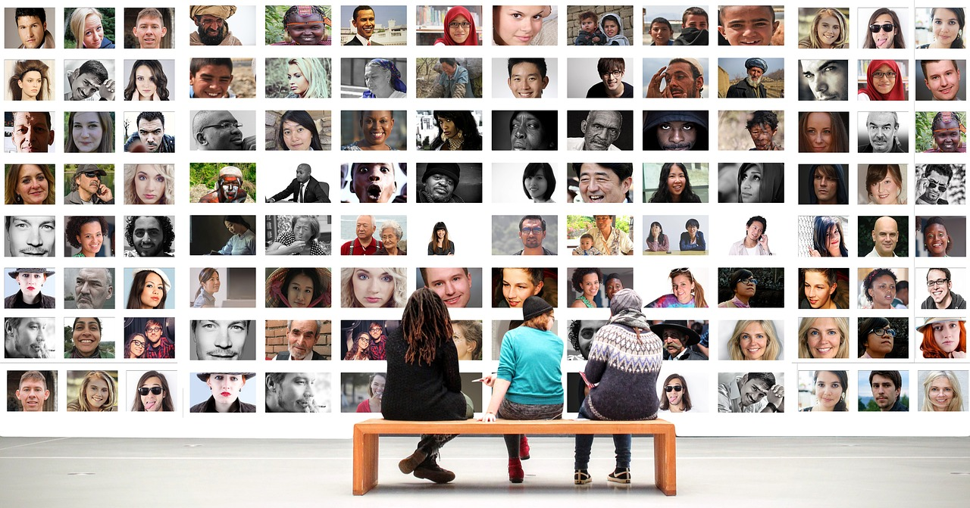

There are differences between individual humans.
Differences between members of a species are called variation.

To talk about in your group
- What are some examples of variation between humans?
- What are the causes of this variation?

Observing and explaining variation

Cats

Pet cats are all one species (Felis catus).

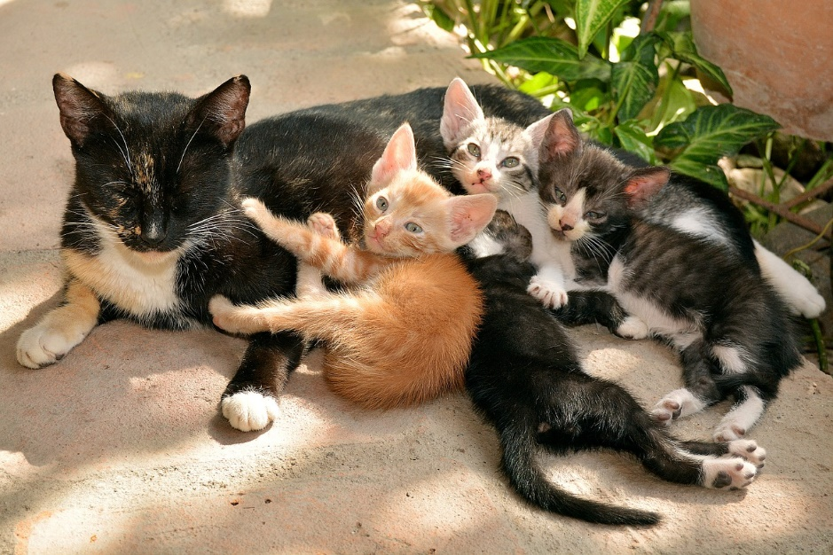

There are differences between the individual cats in the photograph.
Differences between members of a species are called variation.

To talk about in your group
- What are some examples of variation between the cats?
- What are the causes of this variation?

Observing and explaining variation

Sunflowers

The sunflowers in the photograph are all one species (Helianthus annuus).

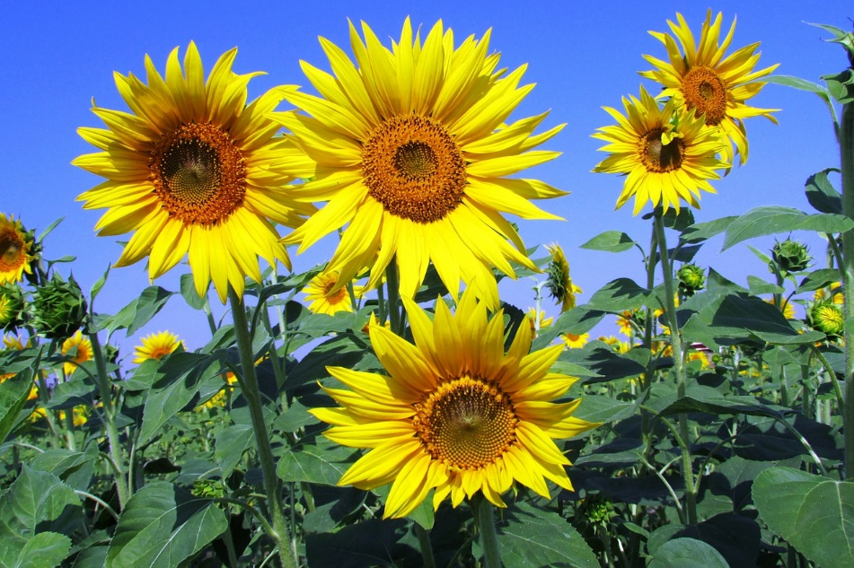

There are differences between the individual sunflowers.
Differences between members of a species are called variation.

To talk about in your group
- What are some examples of variation between the sunflowers?
- What are the causes of this variation?

Biology > Big idea BVE: Variation, adaptation and evolution > Topic BVE3: Evolution > Key concept BVE3.1: Explaining evolution
Response activity
Observing and explaining variation

Overview
Learning focus: | The characteristics of a species can change over generations as advantageous adaptations become more common; this is evolution, and can be explained by a process of natural selection.
Observable learning outcome: | Recognise that there is variation between individuals within a species, and that only genetic variation can be inherited.
Activity type: | Challenge to thinking, discussion
Key words: | variation, species, genome, heredity

This activity can help develop students’ understanding of the presence and causes of variation within a species, through group discussion to challenge misunderstandings revealed by the following diagnostic question:
- Diagnostic question: Variation
What does the research say?
Various researchers (e.g. Deadman and Kelly, 1978; Hackling and Treagust, 1982; Gott et al., 1985; Gregory, 2009; Cisterna, Williams and Merritt, 2013; Allen, 2014) have described common misunderstandings about variation and its causes, which can persist in students up to undergraduate level, including that:
- variation is only caused by environmental factors (students are much less likely to suggest sexual reproduction, inheritance or differences in the genome as causes of variation, even when given a scenario in which environmental conditions are said to remain constant);
- teleological arguments such as that variation occurs to satisfy a need, or in order to improve;
- acquired characteristics (variation resulting from interaction with the environment or from learning) can be passed from parents to offspring.
Gregory (2009) summarises numerous studies in which it was found that when students of various ages were asked to explain evolution by natural selection, very few explicitly included ideas about variation within species (a fundamental requirement for evolution by natural selection, in which the natural variation within populations of a species can cause some individuals to have a survival and therefore reproductive advantage when environmental conditions change).
Ways to use this activity
Students should complete this activity in pairs or small groups, and the focus should be on discussion within the group, structured around the questions provided on the worksheet/presentation. Giving each group one worksheet to complete between them is helpful for encouraging discussion, but each member should be able to report back to the class. Listening in to the conversations of each group will often give you insights into how your students are thinking.
The photographs provided on the worksheet/presentation can be used as stimulus for discussion, or students could look for examples of variation within the people in the class, within living plants or animals in the science lab, within their own family photographs, or within other suitable photographs (e.g. of celebrities or wild animals).
The quality of the discussions can be improved with a careful selection of groups; or by allocating specific roles to students in each group. For example, you may choose to select a student with strong prior knowledge as a scribe, and forbid them from contributing any of their own answers. They may question the others and only write down what they have been told. This strategy encourages contributions from more members of each group.
Jigsaw groups approach
You may wish to divide the class into “expert groups”, such that different groups discuss (and become “experts” in) each of the different examples (humans, cats, sunflowers, and so on). Groups could then report back to the class, or the students could be rearranged into “jigsaw groups” comprising one expert for each example to report to the group on examples and causes of variation.
Expected answers
Students are likely to suggest many different examples of variation, e.g. height, body mass, colour of skin/fur/hair/eyes, physical damage, and so on.
They should also suggest possible causes of variation, e.g. differences in the genome/DNA/genes/inherited genetic material, differences in lifestyle or environment (or named examples), or ideas about sexual reproduction and random inheritance of traits from each parent.
Acknowledgments
Developed by Alistair Moore (UYSEG).
Images: humans – pixabay.com/geralt (2944065); cats – pixabay.com/disoniador (1469477); sunflowers – pixabay.com/Vijayanarasimha (268015)
References
Allen, M. (2014). Misconceptions in Primary Science, Second edn Berkshire, UK: Open University Press.
Cisterna, D., Williams, M. and Merritt, J. (2013). Students' understanding of cells & heredity: patterns of understanding in the context of a curriculum implementation in fifth & seventh grades. American Biology Teacher, 75(3), 178-184.
Deadman, J. A. and Kelly, P. J. (1978). What do secondary school boys understand about evolution and heredity before they are taught the topics? Journal of Biological Education, 12(1), 7-15.
Gott, R., et al. (1985). Science in Schools: Ages 13 and 15. Report No. 3. Assessment of Performance Unit. Department of Education and Science, HMSO, London, UK.
Gregory, T. R. (2009). Understanding natural selection: essential concepts and common misconceptions. Evolution: Education and Outreach, 2, 156-175.
Hackling, M. W. and Treagust, D. F. (1982). What lower secondary students should understand about the mechanisms of inheritance, and what they do understand following instruction. Research in Science Education, 12, 78-88.

